To Absent Friends 2026
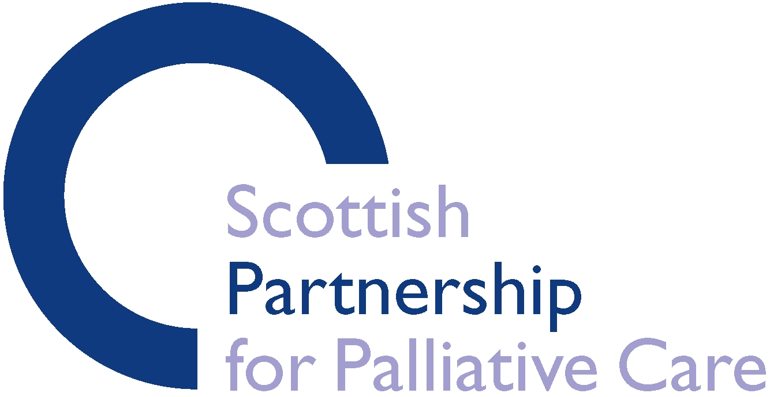
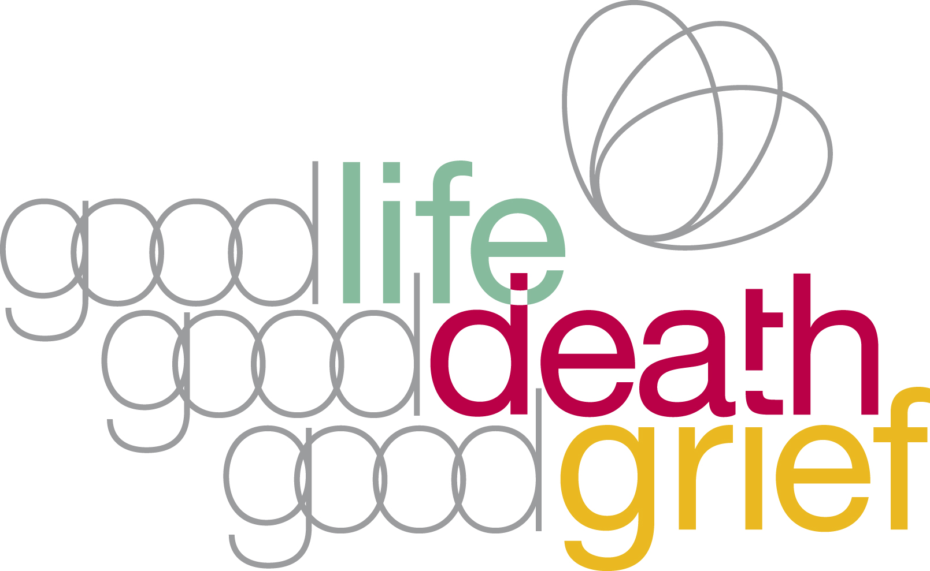
Small Grants Programme
Application Form

Please ensure you have read the guidance notes that support this programme prior to completing this application form.

Part one – Your organisation

- What is your organisation’s name, address and bank details?

Organisation name

Organisation’s address and post code

Organisation’s bank account number and sort code (where we will pay the money if your application is successful)

Please briefly describe what your organisation does, and provide your organisation’s web address if available.

What type of organisation are you? (please choose one)

Voluntary or community organisation Go to question 2.1

Statutory body (eg NHS Board, Council etc) Go to question 2.2

Other Go to question 2.3

1.1 Are you a registered charity? NO YES

If YES, what is your registered charity number?

1.2 What type of statutory body are you?

1.3 What type of organisation are you?

- Who is the main contact for this application?

Title Forenames

Surname

Email address

Phone Number

Part two – About your project or event

- What is the name of your project or event?

- Are you applying for a ‘community grant’ or a ‘public grant’?
Please tick one box:
Community grant

(Community grants can be used to support private remembrance events for a particular community.)
Public grant

(Public grants can be used to support interactive public events freely open to members of the public.)
- Please describe the project or event for which you will use the funding.

- When will it take place?

(The festival takes place 1-7 November)

- How much will it cost?

- How much are you requesting?

- Please provide an overview of the total costs involved, including a breakdown of how the GLGDGG grant would be spent.

- Which of the following aims are you trying to meet with your event?
(tick as many boxes as apply)

10.1 Remembering and/or celebrating a person or people who have died,

either recently or further back.

  - Strengthening community connections - bringing people together

to share stories and solace.

Part three – finishing your application
Please tick the boxes below to complete your application for funding

All the questions on the application form have been completed

You are authorised by your organisation to apply for funding

You agree to spend any funding allocated in line with the intentions
as set out in this application and by 30 November 2026.

You agree to email a photograph and 300 words for inclusion on

www.toabsentfriends.org.uk by 9 October 2026.

You agree to supply a report of your project/event after it is completed,

along with receipts for expenditure against the grant if requested. (We’ll
email you a template report if your funding application is successful.)

You agree that any equipment purchased will remain the property

of the organisation and will not be transferred to an individual

Your organisation has signed up as an organisational member of the

Good Life, Good Death, Good Grief alliance.

If your organisation has not signed up you can do so at:
https://www.goodlifedeathgrief.org.uk/members-sign-up/

Please now email a copy of this form to: samara@palliativecarescotland.org.uk by 12pm on Wednesday 2 September 2026.

Signed .................................................... Date ..................................
Good Life, Good Death, Good Grief is an initiative of the Scottish Partnership for Palliative Care,
a Company Limited by Guarantee. Registered in Scotland No: 133003. Registered Charity SC017979

